Doxy Me-Patient View
You will receive an invite to your virtual session via text message.
- Click the link inside the message.
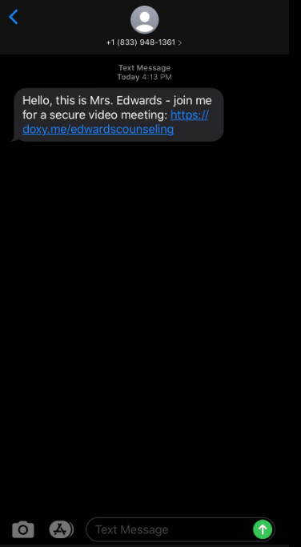
- Type your name in the box provided and click Check In.
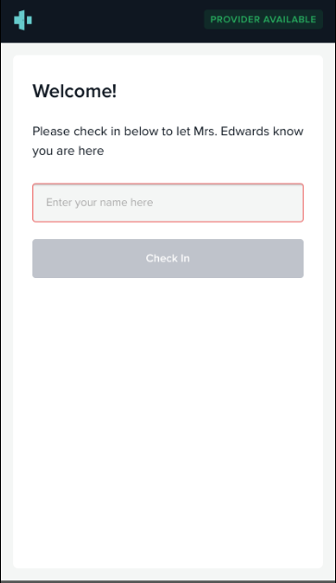
- Click “Enable Camera” .
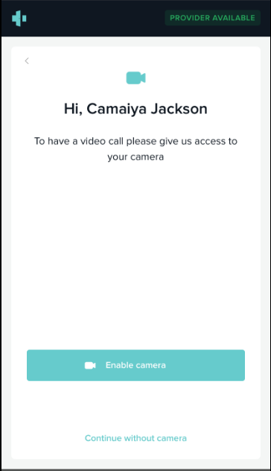
- You will be directed to the virtual waiting room, until your clinician begins session. If you need to message your clinician click the message icon.
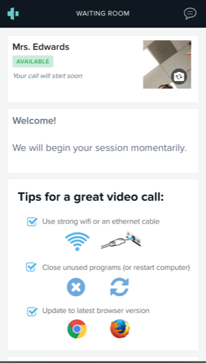
If you have any questions, please give our office a call.

