VSEE-Patient View
-You will receive an invite via email, to enter the session so be sure to provide your Clinician with a correct and current email address.
1. Once you receive the invite via email, click the green button.
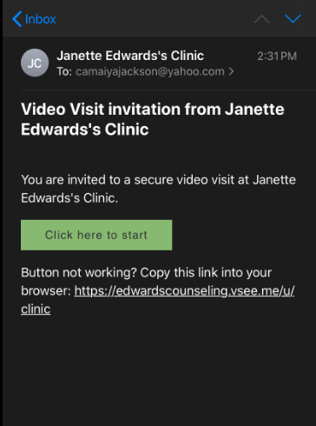
You will be directed to this screen.
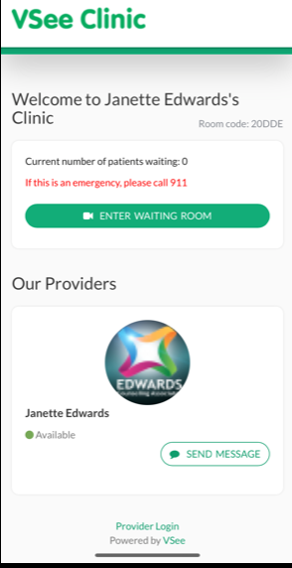
2. Click “Enter Waiting Room.
*Note the room code *

3. Select one of these options before entering the waiting room.
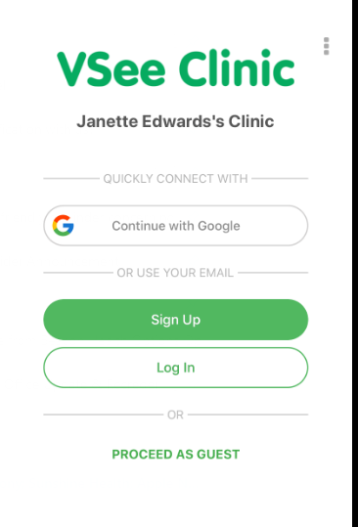
You can proceed as a guest without setting up an account.
If you choose to create an account click “Sign Up” and return to this page to login once sign-up is complete.
OR
4. Type in your First & Last name.
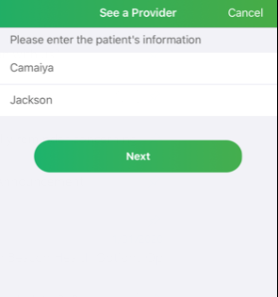
5. Type in a reason for the visit (optional) – you can type something like “counseling session”.
You can add a photo as well if you would like.
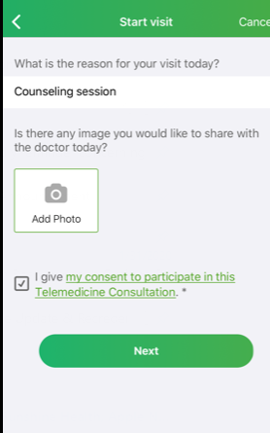 6. CLICK the check box to authorize the virtual session.

7. Click the check box to select the session type.

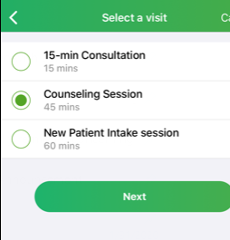
8. Click the green button to enter the waiting room.
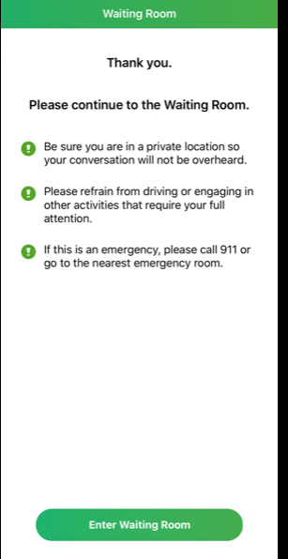
9. This video screen should appear, and you will wait here until your Clinician begins session. If you need to message your clinician you may click the message icon to do so.
